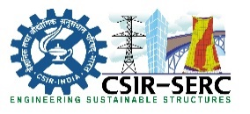
सी.एस.आई.आर-संरचनात्मक अभियांत्रिकी अनुसंधान केन्द्र
CSIR-STRUCTURAL ENGINEERING RESEARCH CENTRE
(वैज्ञानिक तथा औद्योगिक अनुसंधान परिषद Council of Scientific and Industrial Research)
सी.एस.आई.आर परिसर CSIR CAMPUS, तरमणि TARAMANI, चेन्नै CHENNAI - 600 113. भारत INDIA

दूरभाष Tel: 044-22549108/09, 22541238 फैक्स Fax: 044-22542211 ई-मैल E-mail:puroff@serc.res.in.

Description | Our tender reference | Govt. eProcurement system Tender ID No.&date | Bid Submission End date | Bid Opening Date | Mode of tender
Tri-axial force transducer,etc. | A3(51046)2018/Pur dt.15.11.2018 | 2018_CSIR_17992_1 dt.15.11.2018 | 04.12.2018 | 05.12.2018 | TWO BID SYSTEM

Tenderers are requested to visit CPPP portal (https://etenders.gov.in/eprocure/app.) and submit their offer accordingly. For tender terms you may visit www.serc.res.in

Only on line tenders are invited.

